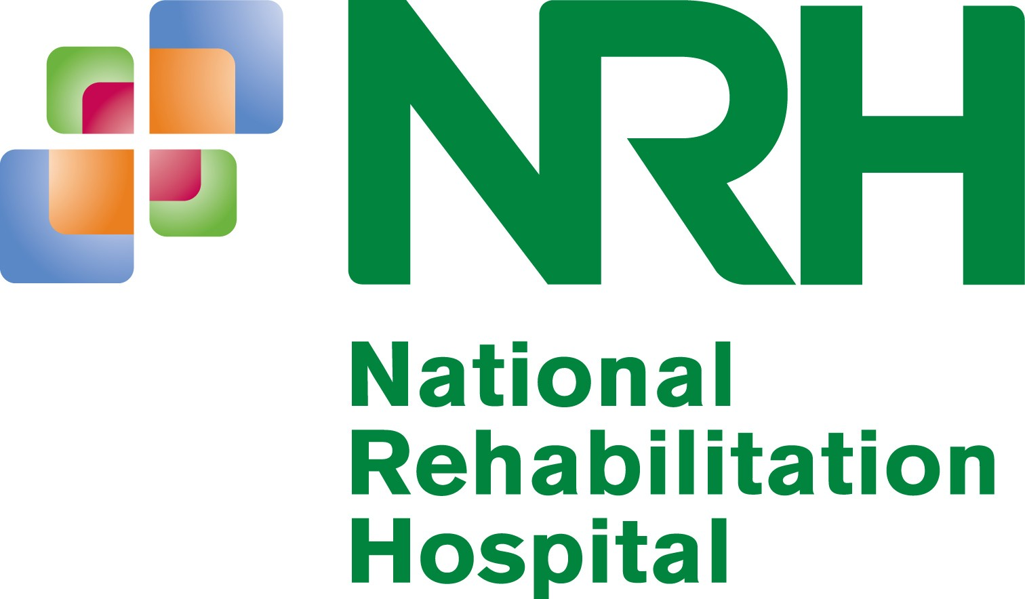

Rochestown Avenue, Dun Laoghaire, Co. Dublin
Tel: 01 – 235 5000 Fax: 01 – 285 1053

REGISTER OF RESEARCH IN PROGRESS, AND COMPLETED, AT NRH

Research Project | Principal Investigator | Co-Investigator | Researcher | Duration of Research
SIRRACT – Stroke Inpatient Rehabilitation Reinforcement of ACTivity: An International MRCS Network | Dr Áine Carroll  Consultant in Rehabilitation Medicine, NRH. | Ms Catherine Cornell, Physiotherapy Department,  NRH | Ms Catherine Cornell, Physiotherapy Department,  NRH | October 2010 -
Assessing Brain-Computer Interface Technology as an Alternative Communications Channel for the Disabled | Dr A. Carroll/ Dr J. McElligott  Consultant in Rehabilitation Medicine, NRH.  Dr Damien Coyle BEng PhD  University of Ulster. | Dr. Jacqueline Stow,  Specialist Registrar in  Rehabilitation Medicine, NRH | Dr. Jacqueline Stow,  Specialist Registrar in  Rehabilitation Medicine, NRH | July 2010 -
Compensatory strategies for activities of daily living (ADL): a comparison of occupational therapists’ expectations and actual use following discharge from rehabilitation for acquired brain injury | Dr Mark Delargy/  Dr Jacinta McElligott  Consultant in Rehabilitation Medicine, NRH | Ms Anne Marie Langan,  Occupational Therapy Manager, NRH.  Prof. Agnes Shiel, Occupational Therapy Department Head,  NUI, Galway. | Ms Nicola Kavanagh,  Occupational Therapy Student,  NUI,  Galway | July 2010 -
Reconstructing sense of self following Acquired Brain Injury: Exploring the influence of autobiographical and working memory | Dr Aine Carroll  Consultant in Rehabilitation Medicine, NRH | Dr Jacinta McElligott, NRH  Dr. Simone Carton, NRH  Dr Jessica Bramham, UCD | Ms Aisling Lennon  School of Psychology,  UCD | May 2010 -
An Investigation into the effects of electrical stimulation training in a spinal cord injured population | Dr Eimear Smith  Consultant in Rehabilitation Medicine, NRH | Dr Brian Caulfield, UCD  Dr Garrett Coughlan, UCD  Dr Louis Crowe, UCD  Ms Kirsti McCormack, UCD | Ms Amanda Carty  Clinical Specialist in Spinal Cord Injury,  NRH | March 2010 -
Self-Regulation of Goals and Psychosocial Adjustment to Amputation | Dr Nicola Ryall  Consultant in Rehabilitation Medicine, NRH | Dr. Simone Carton, NRH  Ms. Patricia Byrne, NRH  Dr. Pamela Gallagher, DCU  Dr. Deirdre Desmond, NUI, Maynooth | Ms Laura Coffey  PhD Student,  School of Nursing,  Dublin City University | January 2010 -
Cognitive impairments in traumatic brain injury novel biomarkers for new treatments | Dr. Mark Delargy  Consultant in Rehabilitation Medicine, NRH | Dr. Paul Dockree, Institute of Neuroscience, TCD | Dr. Paul Dockree, Institute of Neuroscience, TCD | March 2008 -
National Drug-Related Deaths Index | Dr. Jacinta Morgan  Consultant in Rehabilitation Medicine, NRH | Ms. Suzi Lyons, Senior Research Officer, Health Research Board  Ms. Ena Lynn, Research Officer, Health Research Board | Ms. Ena Lynn, Research Officer, Health Research Board | July 2007 -
A Generic Electronic Assisted Technology (EAT) package for Persons with Quadriplegia | Dr. Jacinta McElligott  Consultant in Rehabilitation Medicine, NRH | Michele Verdonck, Senior Occupational Therapist, NRH | Michele Verdonck, Senior Occupational Therapist, NRH | January 2007 -

- 3 -

REGISTER OF RESEARCH COMPLETED AT NRH

Research Project | Principal Investigator | Co-Investigator | Researcher | Completed
The experience of living with spinal cord injury in the early months following discharge from rehabilitation: a qualitative study on a male sample | Dr. Jacinta McElligott  Consultant in Rehabilitation Medicine, NRH | Ms. Maeve Nolan,  Senior Clinical Psychologist,  NRH | Ms. Maeve Nolan,  Senior Clinical Psychologist,  NRH | Completed 2011
Longitudinal Investigation of Cognitive Appraisals, Coping and Psychological Outcomes: A Multicentre European Study | Dr. Eimear Smith/  Dr. Jacinta McElligott  Consultant in Rehabilitation Medicine, NRH | Dr. Simone Carton, NRH  Ms. Maeve Nolan,  Department of Clinical Neuropsychology, NRH | Ms. Maeve Nolan,  Department of Clinical Neuropsychology, NRH | Completed 2011
Caregiver wellbeing: an examination of the coping-appraisel process of caring for individuals with an acquired brain injury | Dr. Jacinta McElligott  Consultant in Rehabilitation Medicine, NRH | Ms. Valerie Twomey,  Brain Injury Programme Manager and Senior Clinical Psychologist, NRH | Ms. Olivia Murphy Psychologist in  Clinical Training,  TCD | Completed 2010
Rehabilitation of Awareness of deficits in Patients with Traumatic Brain Injury Applying a User-Friendly Computerised Intervention Approach | Dr. Jacinta Morgan  Consultant in Rehabilitation Medicine, NRH | Dr Simone Carton, NRH | Ms. Mary Fitzgerald,  Department of Clinical Neuropsychology, NRH | Completed 2010
Optimising the prescription of prosthetic technologies (opptec): Outcome measures for evidence based prosthetic practice and use | Dr. Nicola Ryall  Consultant in Rehabilitation Medicine, NRH | Dr. Pamela Gallagher, DCU  Ms. Sinead Ni Mhurchadha, DCU  Ms. Elisabeth Schaffalitzky, DCU | Ms. Sinead Ni Mhurchadha, School of Nursing, DCU  Ms. Elisabeth Schaffalitzky, School of Nursing,DCU | Completed 2010
Differences in Marital Satisfaction, Coping and Social Support following a Traumatic Brain Injury | Dr. Áine Carroll  Consultant in Rehabilitation Medicine, NRH | Ms. Patricia Byrne,  Clinical Neuropsychologist, NRH | Ms. Anne Marie Casey, Assistant Psychologist, NRH | Completed 2010
Music Therapists’ Strategies in Implementing New Posts within Health Care Settings | Dr. Hugh Monaghan,  Consultant Neuro-paediatrician | Professor Jane Edwards,  Director - Music & Health Research Group, Irish World Academy of Music and Dance,  University of Limerick | Professor Jane Edwards,  Director - Music & Health Research Group, Irish World Academy of Music and Dance,  University of Limerick | Completed  2009
The Prevalence of Osteoporosis in the Disabled Population at the National Rehabilitation Hospital | Dr. Áine Carroll  Consultant in Rehabilitation Medicine, NRH | Dr. Éimear Smith, Specialist Registrar in Rehabilitation Medicine, NRH | Dr. Éimear Smith, Specialist Registrar in Rehabilitation Medicine, NRH | Completed 2009
An exploration of Peri and Post Partum Stroke in the context of Relationships of the Individuals Affected | Dr. Áine Carroll  Consultant in Rehabilitation Medicine, NRH | Ms, Patricia Byrne, NRH Ms. Áine Finan, Dept. Psychology, TCD | Ms. Áine Finan, Dept. Psychology, TCD | Completed 2009
An exploration of child and adolescent sibling’s experience of paediatric traumatic brain injury | Dr. Hugh Monaghan  Consultant in Neuro Paediatric Rehabilitation Medicine, NRH | Dr. Sarah O’Doherty, NRH Ms. Heather Cronin, Dept Psychology, TCD | Ms. Heather Cronin, Dept. Psychology, TCD | Completed 2009
Standards of Practice in Irish and UK Hydrotherapy Pools | Dr. Angela McNamara  Consultant in Rehabilitation Medicine, NRH | Ms. Aoife Langton  Senior Hydrotherapist, NRH | Ms. Aoife Langton  Senior Hydrotherapist, NRH | Completed 2008
Prospective Memory Deficit Following Traumatic Brain Injury: Level of Awareness, rate of Recovery and Psychosocial Outcome | Dr. Mark Delargy  Consultant in Rehabilitation Medicine, NRH | Dr. Simone Carton, NRH  Ms. Melanie Clune,  Dept. Psychology, UCD | Ms. Melanie Clune,  Dept. Psychology, UCD | Completed  2008
Assessing the impact of previous experience, and attitudes towards technology, on levels of engagement in a virtual reality based occupational therapy intervention for spinal cord injury rehabilitation | Dr. Manus McCaughey  Consultant in Rehabilitation Medicine, NRH | Mr. Paul O’Raw,  School of Psychology, UCD | Mr. Paul O’Raw,  School of Psychology, UCD | Completed  2007
Coping and Adjustment following Spinal Cord Injury in an Irish Population | Dr. Angela McNamara  Consultant in Rehabilitation Medicine, NRH | Ms. Suzanne Meenan,  Department of Clinical Neuropsychology, NRH | Ms. Suzanne Meenan,  Department of Clinical Neuropsychology, NRH | Completed 2007
Self Awareness after Brain Injury: emotional distress and executive functioning | Dr. Mark Delargy  Consultant in Rehabilitation Medicine, NRH | Ms. Judith McBrinn,  Psychologist in Clinical Training, NUI Galway | Ms. Judith McBrinn,  Psychologist in Clinical Training, NUI Galway | Completed 2007
An evaluation of virtual reality technology as an occupational therapy treatment tool in spinal cord injury rehabilitation | Dr. Angela McNamara  Consultant in Rehabilitation Medicine, NRH | Mr. Paul O’Raw,  School of Psychology, UCD / Michele Verdonck, Senior Occupational Therapist, NRH | Mr. Paul O’Raw,  School of Psychology, UCD | Completed 2006
Assessment of Perceived Stress amongst Nursing Staff in a Rehabilitation Hospital | Dr. Jacintha More O’Fearall,  Occupational Health Physician, NRH | Ms. Rose Curtis  Occupational Health Nurse, NRH | Ms. Rose Curtis  Occupational Health Nurse, NRH | Completed 2006
Awareness and Sustained Attention following Traumatic Brain Injury | Dr. Mark Delargy  Consultant in Rehabilitation Medicine, NRH | Dr. Simone Carton, NRH  Prof. Ian Robertson, TCD  Dr. Paul Dockree, TCD | Dr. Paul Dockree  Dr. Simone Carton | Completed 2005
An Investigation into the functional independence of individuals with Spinal Cord Injury following discharge. | Dr. Angela McNamara  Consultant in Rehabilitation Medicine, NRH | Ms. Lisa Held, BScOT, NRH | Ms. Lisa Held, BScOT, NRH | Completed 2005
The Reliability of the Community Outing Performance Appraisal (COPA) to assess the abilities of Adults with Acquired Brain Injury | Dr. Mark Delargy  Consultant in Rehabilitation Medicine, NRH | Ms. Fiona Ryan, BScOT, NRH | Ms. Fiona Ryan, BScOT NRH | Completed 2005
An investigation into the occupational status of  persons with incomplete Spinal Cord Injury | Dr. Angela McNamara  Consultant in Rehabilitation Medicine, NRH | Ms. Catherine Logan,  Senior OT, NRH | Ms. Catherine Logan, Senior OT, NRH | Completed  2005
Strategies for Crisis Intervention & Prevention (SCIP): Does it work? | Dr. Simone Carton  Head of Clinical Psychology, NRH | Mr. Ray Messitt,  Nursing Dept, NRH | Mr. Ray Messitt,  Nursing Dept, NRH | Completed 2005
Assessment of Financial Competency in Patients with Acquired Brain Injury | Dr. Mark Delargy  Consultant in Rehabilitation Medicine, NRH | Dr. Simone Carton, NRH  Mr. Nick Kidd,  Dept. Psychology, TCD | Mr. Nick Kidd,  Dept. Psychology, TCD | Completed  2005
A Pilot Study of the Safety and Effectiveness of the Traxon Spinal Cord Repair Stimulator for the Treatment of Complete Spinal Cord Injury in Humans | Dr. Patrick C Murray,  Consultant in Rehabilitation Medicine, NRH | Professor Ciaran Bolger,  Consultant Neurosurgeon,  Beaumont Hospital | Ms. Linda McEvoy | Completed  2004
Psychological Aspects of Amputation: A cross-Sectional Study | Dr. Nicola Ryall,  Consultant in Rehabilitation Medicine, NRH | Prof. Malcolm MacLachlan  Department of Psychology,  Trinity College Dublin | Ms. Olga Horgan | Completed  2004
Traumatic Brain Injury and Subsequent Rehabilitation – Focussing on the Future | Dr. Mark Delargy  Consultant in Rehabilitation Medicine, NRH | Prof. J.P. Phillips/  Dr. Lourda Geoghegan  Dept. of Public Health Medicine, UCD | Dr. Lourda Geoghegan | Completed  2004
Nurses’ Perceptions of their Role as part of the Multi-professional Team in an Acute Rehabilitation Setting |  |  | Ms. Fanchea McCourt  Education Co-ordinator, NRH | Completed  2004
Evaluation of Service Needs and Provisions in Relation to Children and Young People with Acquired Brain Injury in Ireland | Dr. Hugh Monaghan,  Consultant Neuro-Paediatrician, NRH | Dr. Diane Hogan  The Children’s Research Centre, TCD | Dr. Caroline Heary  Dr. Diane Hogan | Completed 2003
Parents’ Perspectives on reintegration of Students with Acquired Brain Injury into the Irish School System |  |  | Ms. Mary O’Connor  School Principal, NRH | Completed  2002

